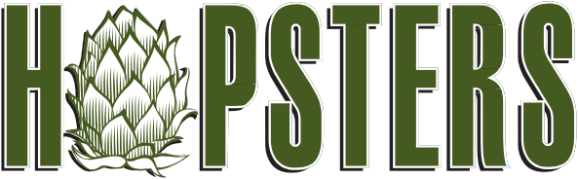

CORPORATE EVENTS & GROUP OUTINGS

Beyond the typical golf events, boat trips or baseball park cookouts, Hopsters offers a unique corporate social event that is perfect for a company’s summer outing, team-building exercise, holiday party or client appreciation event.
At Hopsters, employees work and play together to brew a unique “signature” craft beer in a convivial, social atmosphere offering delicious food and drink.
Hopsters can accommodate groups of up to 90 people, with an option to brew up to 10 kettles of custom craft beer at one time.

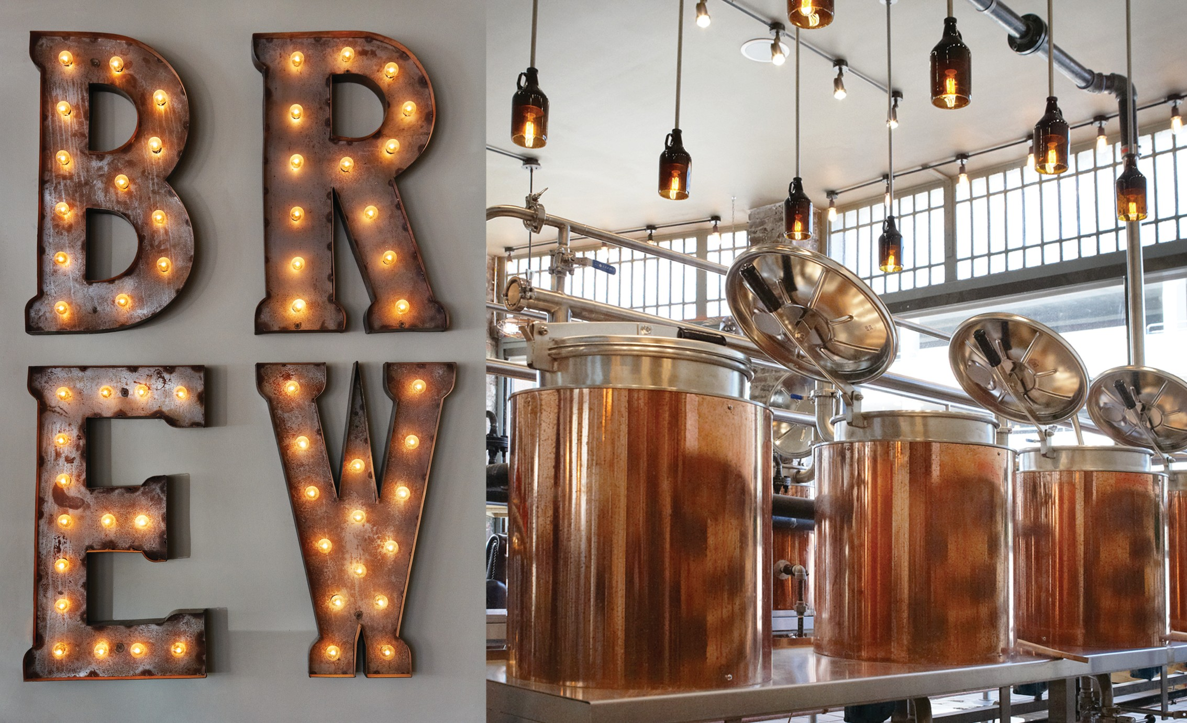Here’s How It Works
Schedule up to 10 kettles and create 30 cases of beer with your own custom labels. The brewing process takes approximately 2-3 hours in total. Leave your beer with us to ferment for 3-4 weeks. Choose from our delivery service, or pick up your own
During the brewing process, patrons can enjoy one of 20 rotating local craft beers on tap, the largest selection of New England craft beers in the state of Massachusetts, local craft liquor cocktails and a bite from the kitchen featuring local charcuterie and artisanal cheeses.

Cost
$125 per-person for first 30 guests, $50 per person up to 90 guests
(maximum of three people assigned to a kettle) includes:
Brewing from a choice of 30 craft beer recipes
All ingredients
Fun and educational session with our concierge brewmasters
Ability to submit custom-designed labels
Approx. 3 cases of beer for each kettle brewed (10 kettles max.)
An array of hand-crafted charcuterie, artisanal cheeses and gourmet flatbreads are available (a la carte or package pricing). Customized menus are also available upon request.
Reservations can be made online at www.hopsters.net or by calling
Hopster’s at 617-916-0752.

FUN

FARM

LOCAL

LEARNING

COMMUNITY

292 Centre Street
Newton, MA

617.916.0752 www.hopsters.net

@hopstersbrew

